Source Transformation

and

Equivalent Source Theorem

A report By

Kibria Golam

Id: 2019380163

**Date: 05/03/20**

# Use Thevenin’s theorem to simplify this circuit, calculate the current flowing through RL, and prove that your simplification is correct.

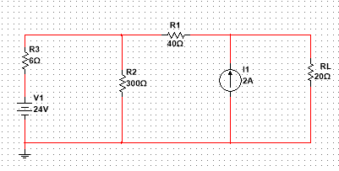

Step 1: Measuring Rth by shorting the voltage source and opening the current source.

Rth= 1v/0.022A= 45.4545

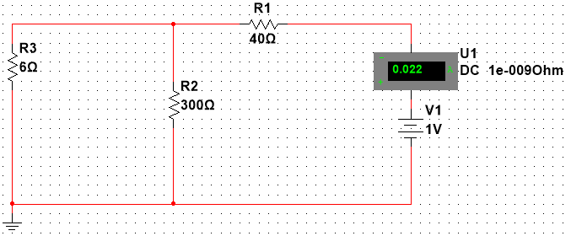

Step 2: Measure the Vth removing RL.

Vth= 115.294V

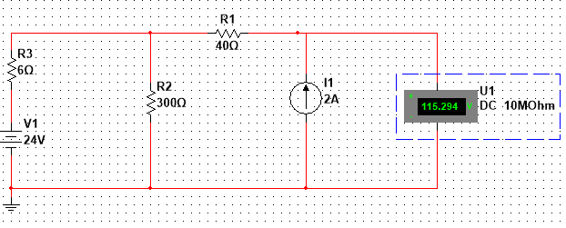

Step3: Finding the current IL through RL using Thevenin’s Equivalent circuit.

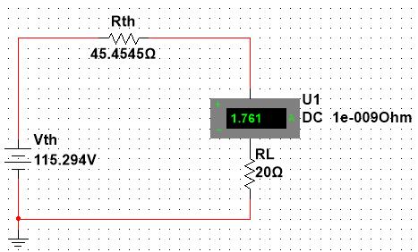

* current through load resistance,IL= 1.761A

**Advantages and disadvantages of open short circuit method, direct measurement method and semi-biased method**

|  |  |  |
| --- | --- | --- |
|  | **Advantages** | **Disadvantages** |
| **Open short circuit method** | No external source is required | doesn’t work if the circuit has a dependent source |
| **Direct measurement method** | No external source is required | doesn’t work if the circuit has a dependent source |
| **Semi-biased method** | semi biased method works in any condition | Requires external source |

**#** Use Norton’s theorem to simplify this circuit, and calculate the current flowing through RL.

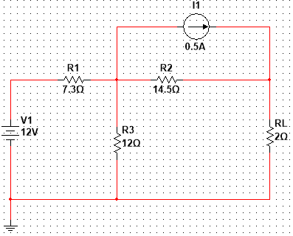

Step 1: Measuring RN by shorting the voltage source and opening the current source. Which is same as Thevenin’s equivalent resistance.

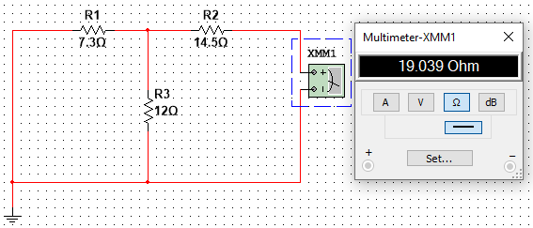

RN = RTh = 19.039 Ohm

Step2: Measure short circuit current Isc by removing Load resistance and shorting the terminals.

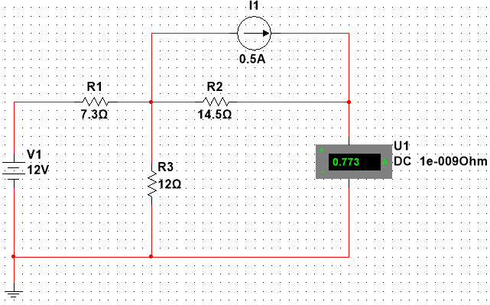

Isc = IN= 0.773A

Step3: Finding the current IL through RL using Norton’s Equivalent circuit.

IL

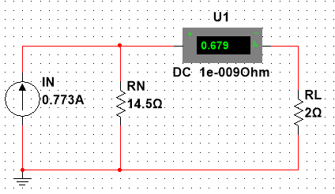

IN= 0.679A

# The internal resistor of ideal voltmeter is infinity, and the internal resistor of ideal ammeter is zero. But practical voltmeter and ammeter is different. Use a practical voltmeter and ammeter to measure the voltage-current characteristic of a linear resistor R=200Ω, the internal resistance of voltmeter is 100 kΩ, and the internal resistance of ammeter is 0.2Ω. How do we connect voltmeter and ammeter so that the error is minimal? Design a circuit and give a description or explanation.

**Circuit:**

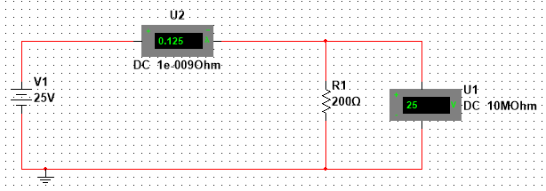

**Datasheet:**

|  |  |  |  |  |  |
| --- | --- | --- | --- | --- | --- |
| Voltage | 5V | 10V | 15V | 20V | 25V |
| Current | 0.025A | 0.05A | 0.075A | 0.1A | 0.125 |
| Resistance | 200Ω | 200Ω | 200Ω | 200Ω | 200Ω |

**Graph:**

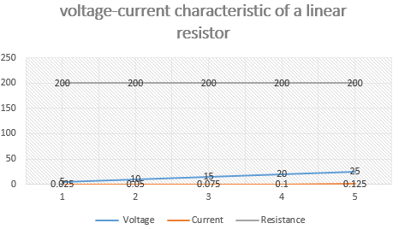

Possible solution to reduce the error of a voltmeter and an ammeter:

The resistance of an ideal voltmeter is near to infinity. If we increase the resistance of a non-ideal voltmeter by putting more non-ideal voltmeter in series, we will be able to reduce the error as less current will leak through the voltmeter. The proposed circuit is shown below.

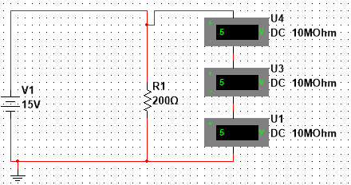

Here the voltage across the 200-ohm resistor can be measured by summing up the measured data of three voltmeters.

For the ammeter, we know that the internal resistance of an ideal ammeter is 0. So, if we apply the same strategy like before, but instead of putting them in series we need to put the ammeters in parallel to reduce the resistance. In this way, we can keep the errors minimal. The proposed circuit is shown below.

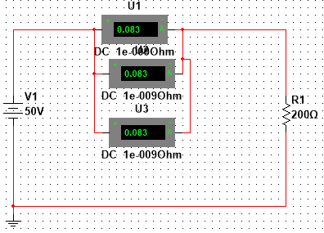

Here, the current flowing through the circuit can be measured be summing up the three ammeters reading.